

Submitted by : Spogmai jan
Roll no : 2430 - 0081
Course : AI lab
Date of submission : 18/02/2026
Submitted to : MAM WARDAH

Assignment no : 01
Task 1:
Write a Python program to find those numbers which are divisible by 7 and
multiple of 5, between 1500 and 2700 (both included)
CODE & OUTPUT:

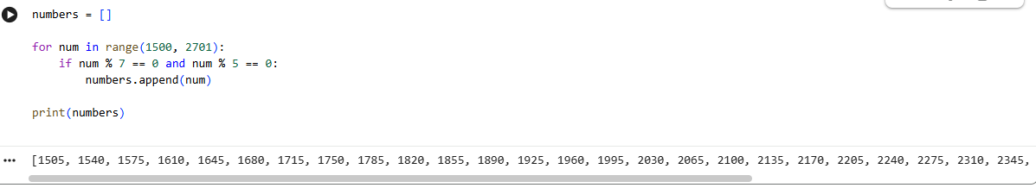
Task 2:
Write a Python program to find numbers between 100 and 400 (both included)
where each digit of a number is an even number. The numbers obtained should be
printed in a comma-separated sequence.
CODE & OUTPUT:
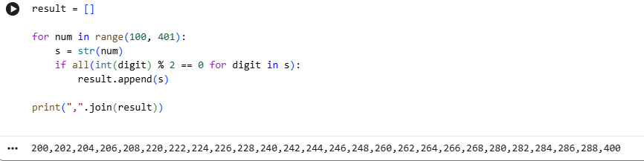

Task 3:
Write a Python program to calculate the sum and average of n integer numbers
(input from the user). Input 0 to finish.

CODE & OUTPUT:

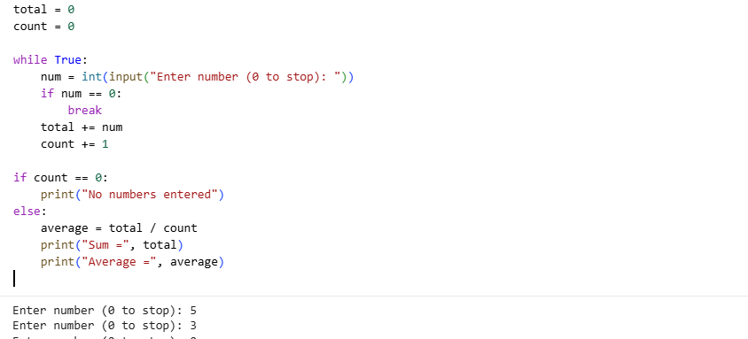
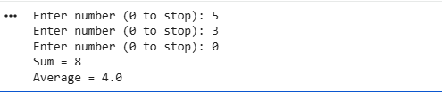

Task 4:
A student will not be allowed to sit in exam if his/her attendance is less than 75%.
Take following input from user
• Number of classes held
• Number of classes attended.
• And print percentage of class attended
• Is student is allowed to sit in exam or not.

CODE & OUTPUT:
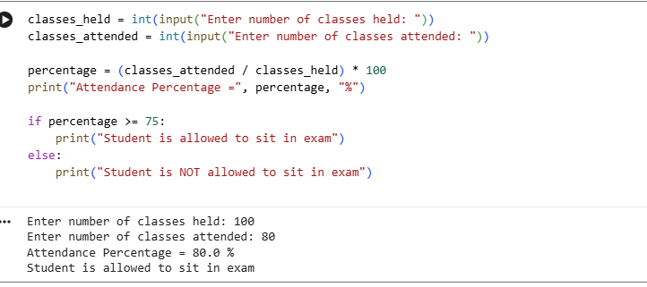
Task 5:
Write a Python program to perform the following tasks using lists:
• Create a list named numbers containing integers from 1 to 5.
• Print the original list.
• Append the number 6 to the list.
• Insert the number 0 at the beginning of the list.
• Print the modified list.
• Remove the number 3 from the list.
• Print the final list.
CODE & OUTPUT:




